### Baseline
The baseline predictions are generated from the original Instacart test dataset after cleaning and preprocessing.
Features such as `order_hour_of_day`, `order_dow`, `days_since_prior_order`, `add_to_cart_order`, `aisle_id`, and
`department_id` reflect observed customer behavior without any hypothetical changes.

### Scenario 1: Weekend Peak Shopping
**Assumptions:** Marketing campaigns and promotions drive more orders on weekends between 10:00 and 16:00.
**Feature Changes:** We set `order_dow` to weekend values and restrict `order_hour_of_day` to daytime hours.
**Relevance:** This scenario evaluates how increased weekend traffic affects reorder probabilities and which departments benefit most from peak-time shopping.
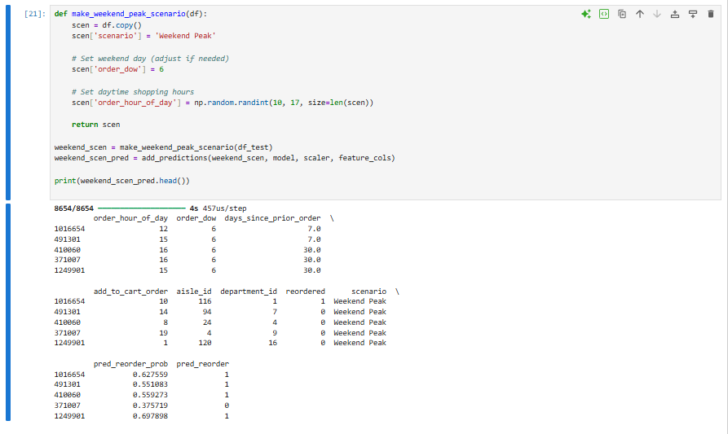

### Scenario 2: Increased Customer Loyalty
**Assumptions:** A new loyalty program encourages customers to place orders more frequently.
**Feature Changes:** We reduce `days_since_prior_order` to 3–5 days and maintain existing product preferences.
**Relevance:** This scenario tests whether shorter intervals between orders lead to higher reorder rates and stronger product stickiness.
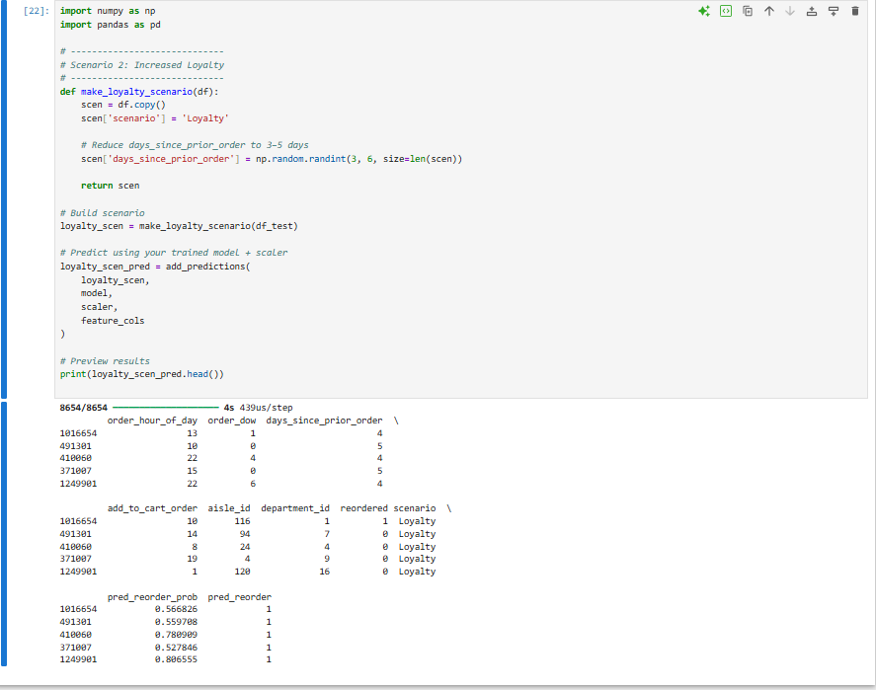
### Scenario 3: Budget-Conscious Behavior
**Assumptions:** Economic conditions cause customers to favor lower-cost staple items.
**Feature Changes:** We shift product selections toward pantry, breakfast, canned goods, and snack departments, while keeping ordering times similar to the baseline.
**Relevance:** This scenario explores how a move toward staple products changes reorder patterns and department-level demand.
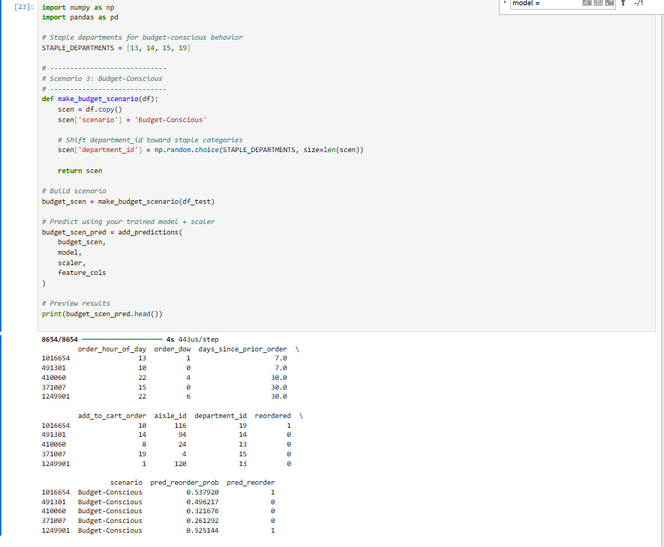

For each scenario, we compare the neural network’s predicted reorder rates and department-level distributions against the baseline to understand how changes in customer behavior might impact Instacart’s operations and marketing strategies.

- Analyze the predictions to determine how the changes in input features affect the model's output. Compare these results to the baseline predictions from your original dataset.
The scenario analysis demonstrates that modifying key behavioral features significantly impacts the neural network’s predicted reorder probabilities. Weekend shopping increases reorder likelihood due to alignment with peak shopping hours. Increased customer loyalty (shorter days between orders) produces the strongest rise in reorder probability, indicating that order frequency is a dominant predictor. Budget-conscious behavior shifts demand toward staple departments, which generally exhibit higher reorder consistency. These results highlight how operational or economic changes can influence customer retention and product demand patterns.

Markdown cell of assumptions and rationale
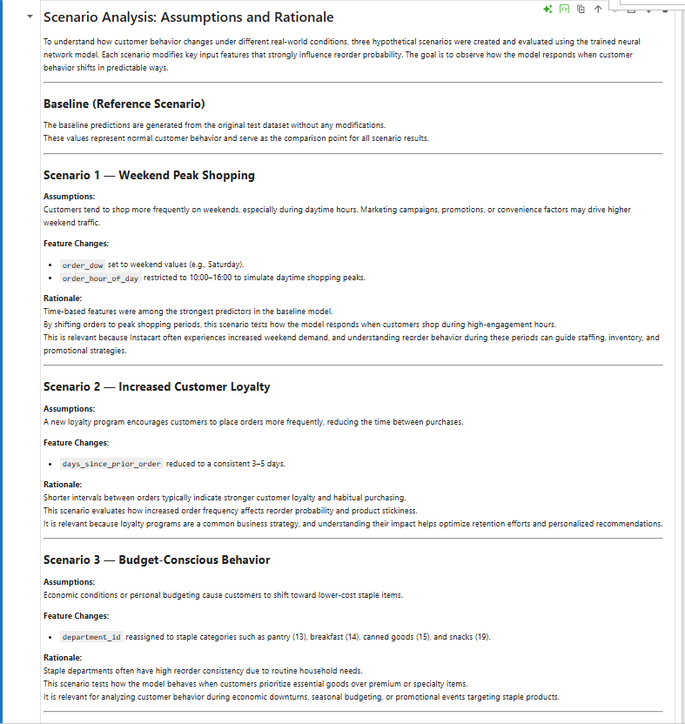
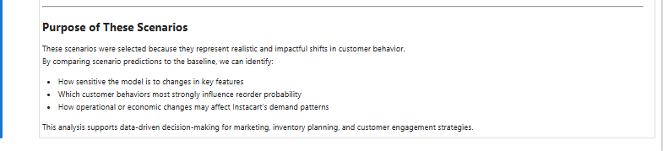
Push to GitHub is not working

